**Create an Executable Spring Boot Standalone Application**

**Add a plugin in pom.xml**:

<plugin>

<groupId>org.springframework.boot</groupId>

<artifactId>spring-boot-maven-plugin</artifactId>

</plugin>

**Package up the application into a jar file**:

mvn clean package -DskipTests

**Use launch4j to create the executable file (.exe) with jre bundle**:

1. Create a new directory and copy jre folder into it.
2. Click launch4j.exe to open Launch4j GUI.
3. In Basic tab, specify output exe file location and the application jar file location. Icon for representing the exe application can also be specified.

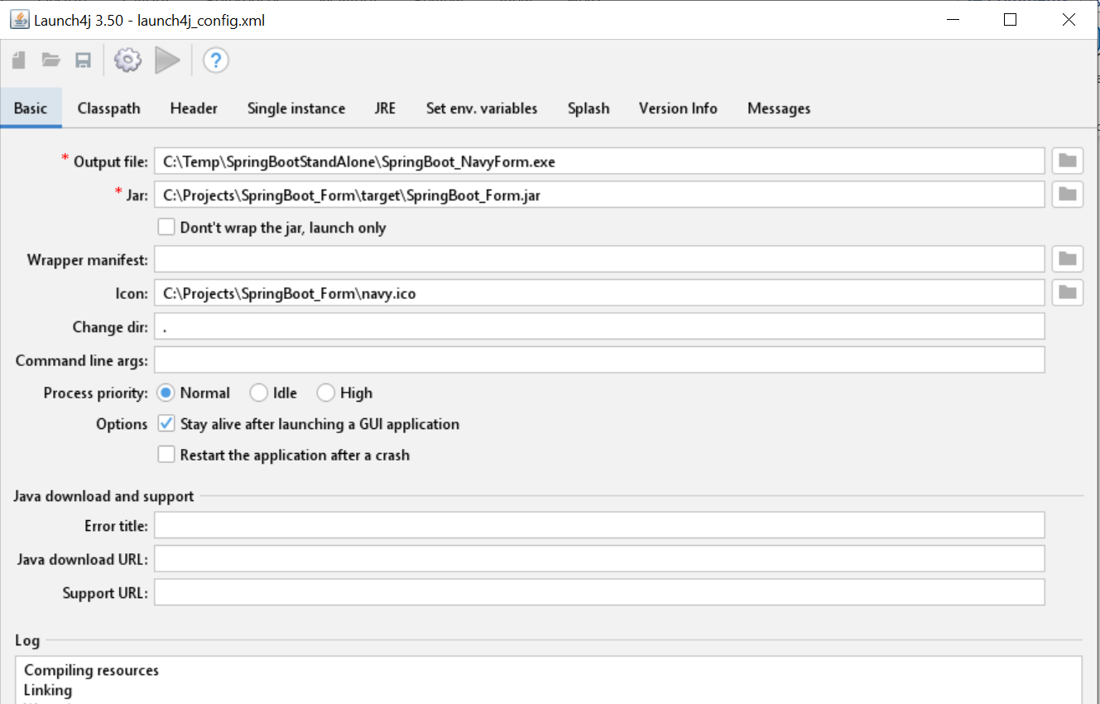

1. In Header tab, select Console option.

1. In JRE tab, specify jre directory in JRE paths.

1. Save the configuration as a .xml file and run it by clicking the gear icon. It should generate the standalone application with .exe file extension.

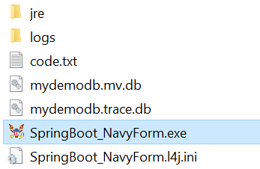

1. Click the .exe file, it should lunch the application console. The parent directory can be zipped up and deployed as a standalone application with jre bundle.

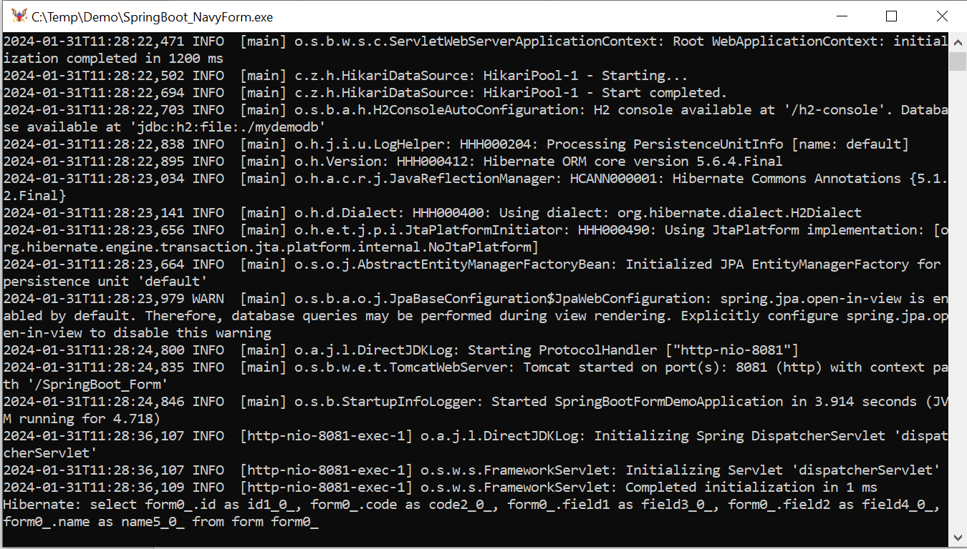

**Can also use command line to run launch4j**:

launch4j launch4j.xml

**Pass run time arguments**

If run time arguments need to be specified, create a .l4j.ini file in the same directory where the .exe file resides. The l4j.ini file's name must correspond to the exe file (myapp.exe: myapp.l4j.ini). Example of contents in the .l4j.ini file:

-Dspring.config.location=classpath:/application.properties

-Dserver.port=8081

**Database Client**

To access the portable database, use DBeaver as a universal SQL client. However, application needs to be terminated to unlock the database.

Alternatively, add spring.h2.console.enabled=true in application.properties and

use http://localhost:8081/SpringBoot_Form/h2-console to access H2 console in browser:

Driver Class: org.h2.Driver

JDBC URL: jdbc:h2:file:./mydemodb

User Name: sa

Password: sa

**Random Server Port and Open Homepage Automatically after Application Starts:**

**public** **class** SpringBootFormDemoApplication {

@Autowired

**private** ServerPortService serverPortService;

**public** **static** **void** main(String[] args) {

ConfigurableApplicationContext context=SpringApplication.*run*(SpringBootFormDemoApplication.**class**, args);

// Access the Spring Boot main application instance

// (SpringBootFormDemoApplication)

SpringBootFormDemoApplication mainApplication=context.getBean(SpringBootFormDemoApplication.**class**);

// Call method of the Spring Boot main application instance

mainApplication.openHomePage();

}

// Launch browser and open home page after Spring Boot application starts.

**private** **void** openHomePage() {

**try** {

**int** port = serverPortService.getPort();

URI homepage = **new** URI("http://localhost:" + port + "/SpringBoot_Form");

System.*setProperty*("java.awt.headless", "false");

Desktop.*getDesktop*().browse(homepage);

} **catch** (URISyntaxException e) {

e.printStackTrace();

} **catch** (IOException e) {

e.printStackTrace();

}

}

}

To make the application run at random server port, set server.port=0 in application.properites file.

**Alternatively use launch4j maven plugin to build .exe when building the application:**

<plugin>

<groupId>com.akathist.maven.plugins.launch4j</groupId>

<artifactId>launch4j-maven-plugin</artifactId>

<version>2.5.0</version> <!-- Check for the latest version on Maven Central -->

<executions>

<execution>

<id>l4j-cli</id>

<phase>package</phase>

<goals>

<goal>launch4j</goal>

</goals>

<configuration>

<headerType>console</headerType>

<jar>${project.build.directory}/${project.build.finalName}.jar</jar>

<outfile>${project.build.directory}/${project.build.finalName}.exe</outfile>

<downloadUrl>http://java.com/download</downloadUrl>

<jre>

<minVersion>1.8.0</minVersion>

<jdkPreference>preferJre</jdkPreference>

</jre>

<versionInfo>

<fileVersion>1.0.0.0</fileVersion>

<txtFileVersion>${project.version}</txtFileVersion>

<fileDescription>${project.name}</fileDescription>

<copyright>Your Copyright Information</copyright>

<productVersion>1.0.0.0</productVersion>

<txtProductVersion>1.0.0.0</txtProductVersion>

<productName>${project.name}</productName>

<internalName>${project.name}</internalName> <originalFilename>${project.build.finalName}.exe</originalFilename>

</versionInfo>

<icon>${project.basedir}/src/main/resources/navy.ico</icon>

</configuration>

</execution>

</executions>

</plugin>

**References**:

Launch4j:

<https://launch4j.sourceforge.net/>

DBeaver:

<https://dbeaver.io/>